Submission
Consultation draft: Occupation Standard Classification for Australia (OSCA)
17th September 2026

The National Farmers’ Federation (NFF) is the voice of Australian farmers.

The NFF was established in 1979 as the national peak body representing farmers and more broadly, agriculture across Australia. The NFF’s membership comprises all of Australia’s major agricultural commodities across the breadth and the length of the supply chain. Operating under a federated structure, individual farmers join their respective state farm organisation and/or national commodity council. These organisations form the NFF.

The NFF represents Australian agriculture on national and foreign policy issues including workplace relations, trade, and natural resource management. Our members complement this work through the delivery of direct 'grass roots' member services as well as state-based policy and commodity-specific interests.

NFF Member Organisations

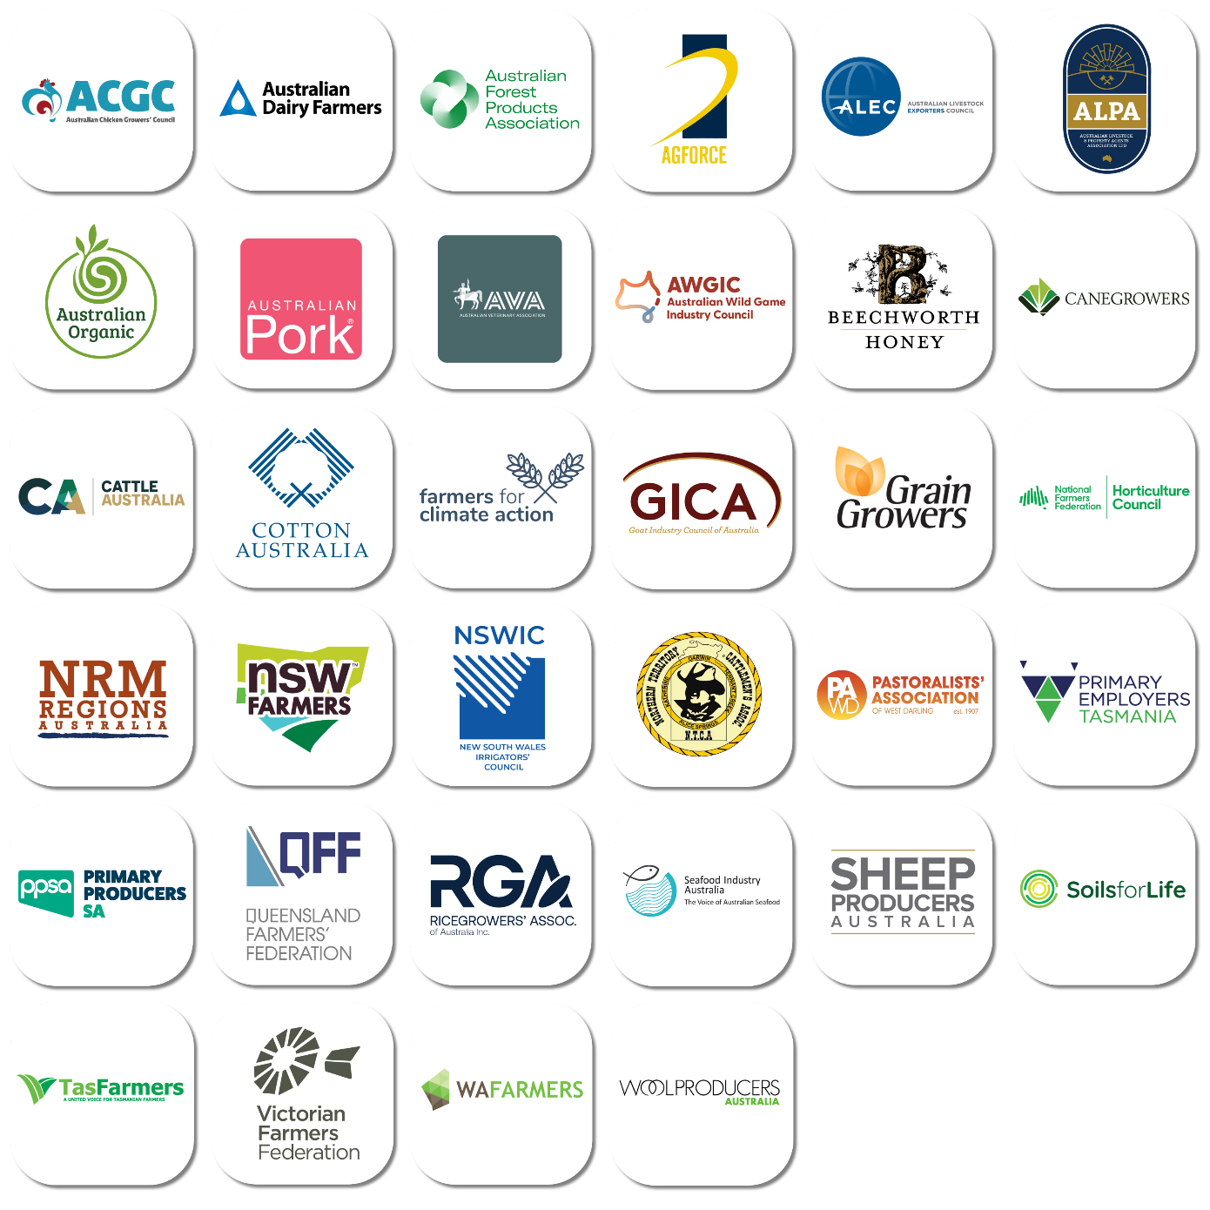
Contents

The National Farmers’ Federation (NFF) is the voice of Australian farmers. 2
NFF Member Organisations 2
Introduction 4
Occupational task profile 4
Occupational task profile 4
Occupational task profile 4
Conclusion 4

OSCA Code 343136: Senior Broadacre Crop Farm Worker

Introduction
The NFF is requesting an acknowledgement of tasks and descriptions of OSCA code 343136 (Senior Broadacre Crop Farm Worker) be responsive to the real-world demands of working on a Grain Farm today. The value of the level of practical experience would, in an ideal world, necessitate a dedicated OSCA code for an experienced Farm Machine Operator. We realise that this is not currently an option. A potential solution is to ensure that the wording of the description and tasks of 343136 offer opportunity for experienced farm machine operators who do not necessarily supervise other staff to be classed under 343136 as their experience, skill, award pay and value to the employer demands.
There are 250,000 workers on broadacre farms in Australia. Our Industry representatives posit that about 1/3 of them would or should meet this level 3 skillset. Where are they being classified elsewhere – potentially as labourers in skill level 4 which is a shocking blindside and does nothing to reflect the true professional skill needed by workers in modern Australian agriculture.

Summary
OSCA code 343136 identifies the occupation of Senior Broadacre Crop Farm Worker. It sits within Major Group 3, Technicians and Trades Workers; Sub-major Group 34, Skilled Animal, Agricultural and Horticultural Workers; Minor Group 343, Primary Production Supervisors and Specialists; and Unit Group 3431, Senior Aquaculture, Crop and Forestry Workers. The occupation captures experienced employees who combine advanced practical production work with day-to-day supervision, machinery operation and maintenance, farm-infrastructure oversight, workforce coordination and the use of precision-agriculture systems. Its separate recognition is important to the accurate measurement of skilled agricultural work and to the design of training, workforce and migration policy. The classification is broadly appropriate, but it should be framed so that senior operational competence—not merely formal line-management responsibility—is the defining feature.
Skill Level 3 is demonstrated through autonomy, judgement, advanced machinery operation and operational responsibility and not by supervisory responsibilities alone.
Purpose and context
This paper examines the scope and policy significance of OSCA code 343136. OSCA is the Australian Bureau of Statistics’ national framework for classifying occupations for statistical purposes. The current OSCA 2024 classification remains operative while the ABS consults on a proposed 2027 update. The August 2026 consultation draft retains code 343136 and describes the occupation as performing skilled tasks on a broadacre crop farm while supervising the planting, cultivation and harvest of broadacre crops. The consultation closes on 18 September 2026, with the updated classification expected in March 2027.
Classification profile
Element | Classification
Occupation code | 343136
Occupation title | Senior Broadacre Crop Farm Worker
Major group | 3 — Technicians and Trades Workers
Sub-major group | 34 — Skilled Animal, Agricultural and Horticultural Workers
Minor group | 343 — Primary Production Supervisors and Specialists
Unit group | 3431 — Senior Aquaculture, Crop and Forestry Workers
Skill level | 3
Listed specialisation | Broadacre Crop Chemical Spray Operator
Skill Level 3 corresponds to an AQF Certificate III that includes at least two years of on-the-job training, an AQF Certificate IV, or at least three years of relevant experience. This formulation is significant in agriculture, where skills are commonly acquired through a combination of vocational education, supervised practice, seasonal exposure and experience across different production conditions.
Occupational task profile
- Overseeing the planting, cultivation and harvesting of broadacre crops.
- Supervising and undertaking the operation and maintenance of broadacre farming equipment and machinery.
- Overseeing the inspection and maintenance of farm infrastructure, including fencing and water-supply systems.
- Organising and training farm workers and supervising work routines and day-to-day production operations.
- Supervising, maintaining and operating data-collection, analysis and production technologies, including GPS, GIS, variable-rate technology, soil sensors and yield monitors.
- Undertaking or supervising the application of pesticides and other agricultural chemicals where required.
The task profile shows that the occupation is neither a conventional farm-labouring role nor a farm-manager role. It is an experienced, operational occupation requiring judgement, technical proficiency and responsibility for coordinating production activities. The word “senior” should therefore recognise an employee’s capacity to work autonomously, diagnose operational problems, guide less-experienced workers and take responsibility for critical production systems, even where the person does not have permanent authority to hire, discipline or dismiss staff.
Workforce and industry relevance
Jobs and Skills Australia report approximately 540 employed persons in this occupation, with 83.5 per cent working full time and a median age of 47 years. These figures should be interpreted cautiously because occupational coding, small sample sizes and the distinction between owner-managers and employees may affect the estimate. Even so, the profile points to a small, experienced and predominantly full-time workforce whose skills are important to broadacre production reliability and productivity.
Recognition of the occupation has broader policy value. Accurate coding can improve labour-market data, reveal shortages that would otherwise be hidden within generic farm-worker categories, support the design of vocational pathways and enable a clearer distinction between entry-level labour, skilled operational work and farm management. The occupation is also relevant to workforce planning because broadacre businesses increasingly rely on high-value machinery, digital agronomy, chemical stewardship, biosecurity practices and production data.
Key classification issues

Supervisory language
A narrow requirement for formal supervision could understate the occupation. Broadacre work is often organised through small permanent teams supplemented by seasonal labour and contractors. A senior worker may lead particular operations, train staff, allocate daily tasks and manage machinery or technology without holding a conventional supervisory title. The lead statement and coding guidance should accommodate this operational reality.
Technology, safety and chemical stewardship
The express reference to GPS, GIS, variable-rate systems, soil sensors and yield monitors appropriately reflects modern broadacre production. However, classification material should remain technology-neutral enough to accommodate autonomous and semi-autonomous machinery, telematics, remote sensing, robotics and new decision-support systems. Chemical application should be recognised as a possible specialisation or task, subject to relevant licensing, work health and safety, environmental and product-use requirements; it should not be treated as a universal prerequisite for the occupation.
Recommended position and proposed wording
- Retain OSCA code 343136 as a separately identified occupation. Its combination of skilled production work, operational leadership and technology use is distinct from both general farm work and farm management.
- Retain Skill Level 3, including recognition of relevant experience as an alternative pathway. This reflects established agricultural skills formation and avoids unnecessary reliance on a single qualification route.
- Clarify the lead statement so that the occupation covers employees who lead or coordinate advanced broadacre operations, whether or not they hold formal line-management authority.
- Preserve practical and technical breadth by expressly covering machinery setup and diagnostics, precision-agriculture systems, production data, infrastructure, work health and safety, biosecurity and environmental compliance.
- Maintain clear boundaries with general broadacre workers, mixed crop-and-livestock roles, growers, farmers and farm managers through inclusion and exclusion guidance based on the substantive duties performed.
- Review the listed specialisation to ensure that “Broadacre Crop Chemical Spray Operator” is not interpreted as the sole or dominant pathway. Consider additional examples such as Precision Agriculture Operator or Senior Cropping Machinery Operator if supported by workforce evidence.
- Support consistent implementation through plain-language coding examples for family farms, corporate farms, contractors and seasonal workforces, and through alignment—where relevant—with training and workforce datasets.

Conclusion
OSCA code 343136 provides necessary recognition of a skilled occupation that is central to contemporary broadacre crop production. Its value lies in capturing the experienced employee who works between entry-level farm labour and enterprise management: operating and maintaining complex equipment, applying production knowledge, coordinating others and using increasingly sophisticated digital systems.
The preferred position is to retain the occupation and Skill Level 3 while refining the description to recognise operational leadership, modern technology and experience-based competency without imposing an unduly narrow formal-supervision test.
Proposed revision and occupational task profile
- Undertakes the planting, cultivation and harvesting of broadacre crops
- Operates and maintains broadacre crop farming equipment and machinery
- Inspects and maintains broadacre crop farm infrastructure, including fencing and water supply systems
- Guiding farm workers and organising work routines and day-to-day production operations.
- Maintains and operates data collection and analysis and production technology systems such as GPS, GIS, variable-rate technology, soil sensors and yield monitors
- May apply pesticides and other agricultural chemicals where required

 | NFF House  14-16 Brisbane Avenue  Barton ACT 2600 | Locked Bag 9  Kingston ACT 2604 | (02) 6269 5666  reception@nff.org.au  nff.org.au

