Submission to the Joint Select Committee on Artificial Intelligence

29 September 2026

The National Farmers’ Federation (NFF) is the voice of Australian farmers.

The NFF was established in 1979 as the national peak body representing farmers and more broadly, agriculture across Australia. The NFF’s membership comprises all of Australia’s major agricultural commodities across the breadth and the length of the supply chain.

Operating under a federated structure, individual farmers join their respective state farm organisation and/or national commodity council. These organisations form the NFF.

The NFF represents Australian agriculture on national and foreign policy issues including workplace relations, trade, and natural resource management. Our members complement this work through the delivery of direct 'grass roots' member services as well as state-based policy and commodity-specific interests.

NFF Member Organisations
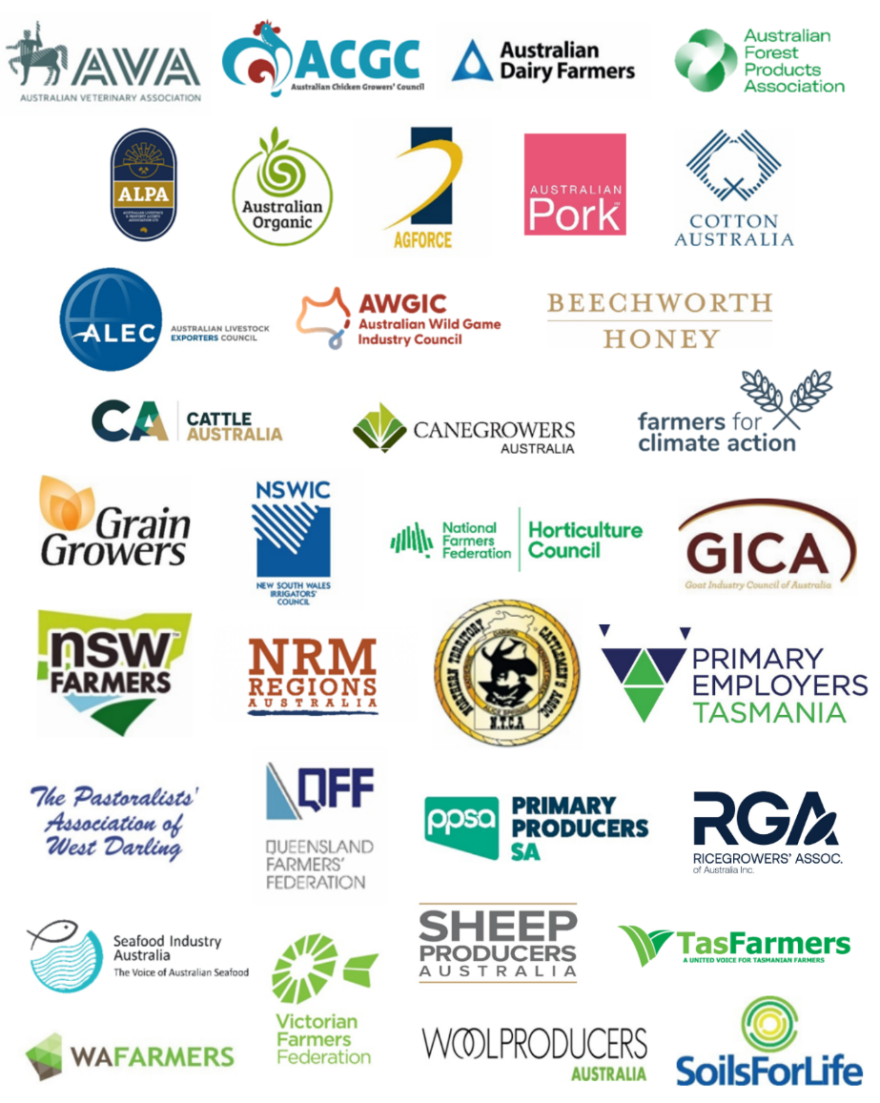
Contents
The National Farmers’ Federation (NFF) is the voice of Australian farmers. 2
NFF Member Organisations 2
NFF’s key messages 3
Introduction 4
ExecutiveSummary …………………………………………………………………………………………………………..……4
Inquiry Principles …………………..……………………………………………………………………………………………..4
Terms of Reference ……………..……………………………………………………………………………………………..…5
Recommendations ……………………………………………………………………………………………………………......7
Conclusion …………………………………………………………………… …………………………………………………….8

Introduction
This submission comments on the terms of reference of the Joint Select Committee on Artificial Intelligence, appointed by the Australian Parliament on 20 August 2026. It adopts a neutral position: artificial intelligence presents material opportunities for productivity, innovation, public administration and regional development, while also creating risks that require proportionate, evidence-based and adaptable policy responses.
The terms of reference are appropriately broad and recognise that AI policy cannot be considered solely as a technology issue. The inquiry should integrate economic, social, legal, workforce, national security and public-sector considerations. Given the Committee’s reporting date of 30 November 2026, its recommendations should distinguish between immediate priorities, matters requiring further evidence and longer-term institutional reforms.

Executive summary
The National Farmers’ Federation welcomes the opportunity to respond to the select Committee’s terms of reference and we comment as follows
- The terms of reference provide a sound basis for examining both the opportunities and risks associated with AI.
- The Committee should apply a risk-based, technology-neutral and outcomes-focused approach, while recognising that some AI uses may justify targeted obligations.
- Regulatory recommendations should begin with a clear assessment of how existing laws apply and where demonstrable gaps remain.
- The inquiry should give specific attention to small and medium enterprises, family businesses, regional communities and sectors of Australian comparative advantage.
- Workforce policy should support consultation, skills development, safe deployment and fair adjustment, without assuming either uniformly positive or uniformly negative employment effects.
- Government use of AI should be transparent, accountable and subject to appropriate human oversight, review and assurance.
- Recommendations should be coordinated with existing Commonwealth, state and territory frameworks and international developments, with periodic review as technology and evidence evolve.

Inquiry Principles
NFF would respectfully submit that the following principles would assist the Committee to assess the matters within its terms of reference consistently.
Proportionality: policy responses should be calibrated to the likelihood and severity of harm, the context of use and the capacity of affected entities.
Evidence and additionality: new measures should address an identified deficiency and add value beyond existing laws, regulators and standards.
Technology neutrality: obligations should generally focus on functions, impacts and outcomes rather than particular models or products, while allowing targeted treatment where distinctive risks are demonstrated.
Accountability across the lifecycle: responsibilities should be clear for developers, deployers, procurers and users, having regard to their practical control over risks.
Contestability and human oversight: consequential decisions should be explainable, reviewable and capable of appropriate human intervention.
National consistency and interoperability: Commonwealth, state and territory approaches should minimise duplication and, where appropriate, align with trusted international standards.
Adaptability: governance arrangements should support monitoring, evaluation and timely revision as capabilities and evidence change.

Terms of reference

Productivity, resilience, competitiveness and regional benefits
NFF would submit that the Committee should examine the conditions under which AI produces measurable economic and social value, rather than treating adoption as an end in itself. Relevant considerations include productivity, service quality, resilience, diffusion of innovation and the distribution of gains between firms, workers, consumers and communities.
Regional participation will depend on connectivity, digital infrastructure, access to data and computing resources, local capability and practical support for adoption. Sector-specific evidence should be sought from agriculture, resources, health and medical research, advanced manufacturing, financial services and defence industry, while avoiding assumptions that a single model of adoption will suit all sectors or locations.

Adoption by small, medium and family businesses
Barriers to proper implementation of AI may include cost, uncertainty about legal obligations, limited technical expertise, data readiness, cyber security, vendor dependence and difficulty assessing product claims. The Committee, in NFF’s view, should distinguish between barriers that warrant public intervention and ordinary commercial constraints. Options for consideration include practical guidance, shared assurance tools, demonstration projects, standards support, workforce training and improved access to independent advice.

Sovereign capability, data and infrastructure
NFF believes that “Sovereign capability” should be defined with precision. It may encompass domestic research, skilled personnel, trusted infrastructure, access to computing capacity, control over sensitive data, procurement resilience and the ability to adapt or evaluate models in Australia. Full domestic self-sufficiency may be neither feasible nor necessary; the policy objective should be the level of capability and control required for resilience, security and economic opportunity.
Domain-specific models trained on Australian data may offer advantages in sectors such as agriculture, health and public administration, but their development must account for privacy, confidentiality, Indigenous data governance, intellectual property, data quality and cyber security. The Committee should consider models for trusted access and data sharing that preserve legitimate rights and safeguards.

Workforce, skills and job quality
NFF believes that this is one of the most important issues in the mix when considering proper implementation of AI. AI may automate tasks, augment workers, create new roles and alter the organisation and quality of work. Effects will vary by occupation, sector, region and firm size. NFF believes that the Committee should seek disaggregated evidence and avoid treating exposure to AI as equivalent to job displacement.
Relevant policy issues include foundational digital literacy, specialist skills, vocational and tertiary education, management capability, consultation with workers and employers, work health and safety, privacy, surveillance, performance management and access to training. Existing workplace laws and institutions should be assessed before recommending additional obligations. Where change is rapid or concentrated, adjustment support should be timely and targeted.

Commonwealth use of AI
There is little doubt that AI may improve service delivery, administration and evidence-based decision-making. Government also bears heightened responsibilities because its decisions can affect rights, entitlements and access to essential services. The Committee should examine implementation of the Commonwealth policy for responsible use of AI, including accountable officials, transparency statements, internal registers, staff training, impact assessment and incident management.
For higher-impact uses, minimum safeguards should include a legally accountable decision-maker, meaningful human oversight, records sufficient for audit, clear notice where appropriate, accessible review pathways, procurement assurance and independent evaluation. Transparency should be balanced against privacy, security and legitimate confidentiality.

Existing laws and possible regulatory gaps
The Committee should map the application of existing privacy, consumer, competition, corporations, employment, work health and safety, discrimination, administrative, criminal and sector-specific laws. The central questions are whether those laws apply clearly, whether regulators have adequate powers and technical capability, and whether enforcement or remedy gaps arise in practice.
Possible responses range from guidance and standards to amendments of existing statutes, regulator coordination and targeted duties for defined high-risk uses. A dedicated AI Act should not be assumed or excluded at the outset. Any case for new legislation should identify the regulatory objective, scope, responsible parties, interaction with existing law, compliance costs, enforcement arrangements and review mechanisms.

Intellectual property, copyright and Australian content
The inquiry should consider the legitimate interests of creators, cultural institutions, media organisations, researchers, technology developers and users. Key issues include lawful access to training material, transparency, licensing, attribution, remuneration, exceptions for research and innovation, enforcement practicality and the treatment of outputs. Recommendations should be consistent with Australia’s international obligations and supported by evidence about market impacts.

Risks, harms and protections
Risks differ materially across fraud and scams, deceptive synthetic media, unsafe products, privacy intrusion, discrimination, erroneous decisions and harms to children or vulnerable people. The Committee should assess each risk by reference to affected persons, causal pathways, scale, reversibility and the adequacy of existing prevention, redress and enforcement mechanisms.
Potential measures include authentication and provenance standards, platform and provider duties proportionate to control, public awareness, stronger scam disruption, age-appropriate safeguards, testing and monitoring, incident reporting and accessible remedies. Measures should be evaluated for effectiveness, enforceability and unintended effects on legitimate expression, research and innovation.

National security, cyber security and critical infrastructure
AI can strengthen threat detection, intelligence analysis and system resilience, while also enabling malicious automation, influence operations and attacks on critical infrastructure. The Committee should examine secure procurement, supply-chain assurance, model and data security, evaluation capability, workforce expertise and information sharing between government and industry.
National security measures should preserve lawful oversight, accountability and civil liberties. Recommendations should distinguish between ordinary commercial AI, dual-use capabilities and systems with direct implications for defence, intelligence or critical infrastructure.

International alignment and environmental impacts
Australia should seek interoperability with trusted international standards and assurance practices where this reduces compliance costs and supports trade, while retaining the ability to address Australian legal, cultural and strategic priorities. The Committee should also consider the energy, water, land-use and infrastructure implications of AI computing, together with opportunities for efficiency and innovation. Reporting and policy responses should be proportionate to material impacts and coordinated across jurisdictions

5. Recommendations
NFF respectfully submits that the committee should
- Adopt a risk-based, technology-neutral and outcomes-focused framework for assessing all terms of reference.
- Publish a clear map of existing laws, regulators, standards and government initiatives relevant to AI before recommending new obligations.
- Identify regulatory gaps by reference to evidence of harm, uncertainty, inadequate remedies or enforcement limitations.
- Assess the costs and benefits of options for small and medium enterprises, family businesses, regional communities and not-for-profit organisations.
- Seek sector-specific evidence, including from agriculture and other areas of Australian comparative advantage, and distinguish between general-purpose and domain-specific uses.
- Recommend practical measures to improve skills, management capability, safe adoption and workforce adjustment, supported by consultation with employers, workers and education providers.
- Strengthen assurance for consequential Commonwealth AI uses through accountability, impact assessment, human oversight, auditability, transparency and review.
- Define sovereign capability and data sovereignty in operational terms, linked to identified resilience, security and economic objectives.
- Promote national consistency and international interoperability while avoiding unnecessary duplication across jurisdictions and regulators.
- Provide staged recommendations: immediate administrative actions, medium-term regulatory reforms and matters requiring further research or consultation.
- Include review and evaluation mechanisms so that policy settings can respond to technological and market developments.

6. Conclusion
The Committee’s terms of reference provide an appropriate foundation for a comprehensive examination of AI in Australia. A durable policy response will require balance: supporting beneficial adoption and domestic capability, protecting people and institutions from material harm, and avoiding unnecessary or duplicative regulation. The Committee can add greatest value by grounding its recommendations in evidence, clarifying the respective roles of existing laws and new measures, and establishing a framework capable of adapting as AI technologies and their uses evolve.

 | NFF House  14-16 Brisbane Avenue  Barton ACT 2600 | Locked Bag 9  Kingston ACT 2604 | (02) 6269 5666  reception@nff.org.au  nff.org.au

