Strengthening Australia’s legislative response to modern slavery in supply chains

National Farmers’ Federation response to discussion paper

24 September 2026

The National Farmers’ Federation (NFF) is the voice of Australian farmers.

The NFF was established in 1979 as the national peak body representing farmers and more broadly, agriculture across Australia. The NFF’s membership comprises all of Australia’s major agricultural commodities across the breadth and the length of the supply chain.

Operating under a federated structure, individual farmers join their respective state farm organisation and/or national commodity council. These organisations form the NFF.

The NFF represents Australian agriculture on national and foreign policy issues including workplace relations, trade, and natural resource management. Our members complement this work through the delivery of direct 'grass roots' member services as well as state-based policy and commodity-specific interests.

NFF Member Organisations
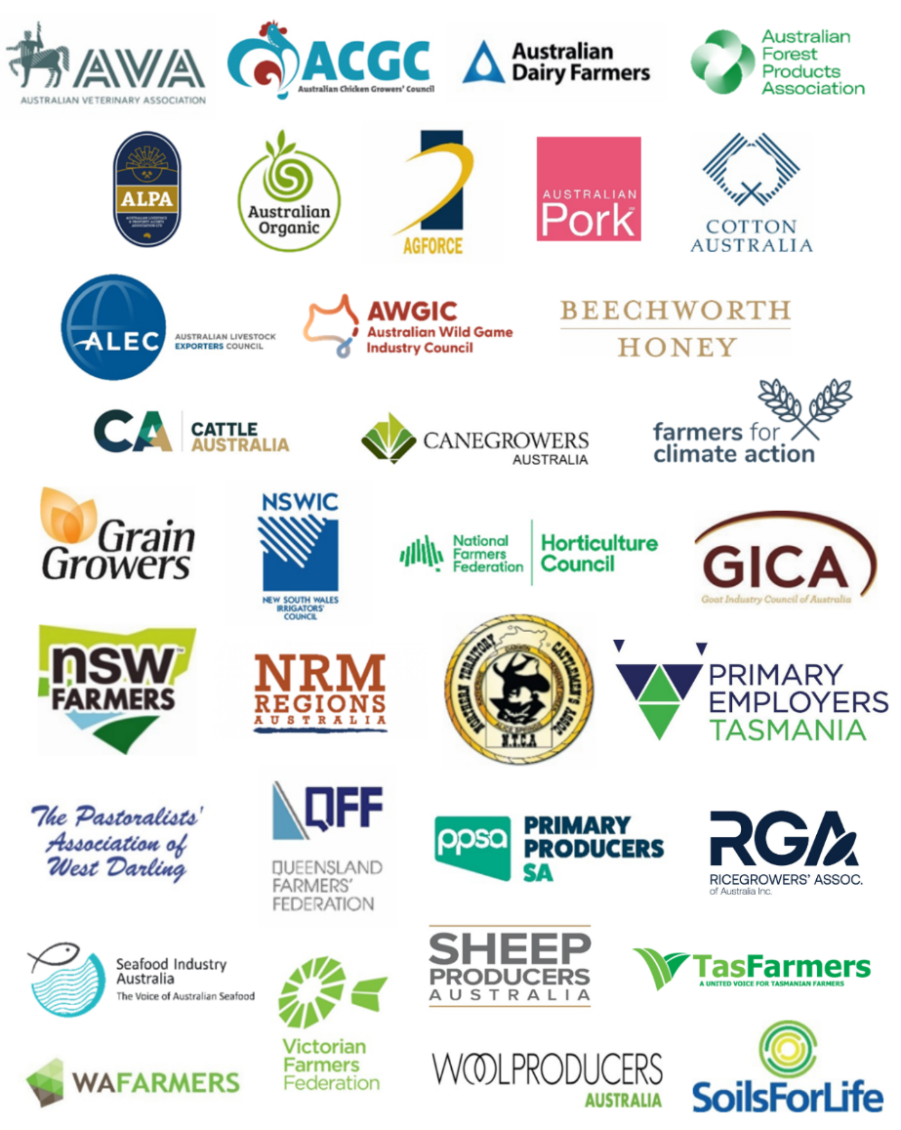
Contents
The National Farmers’ Federation (NFF) is the voice of Australian farmers. 2
NFF Member Organisations 2
Executive summary 4
Recommendations 4
1. General position on reform 4
2. Failure to prevent offence 5
3. Civil penalties and enforcement 5
4. Mandatory due diligence 5
5. High-risk declarations 6
6.Deferred prosecution agreements 6
7. Remedies for victims and worker protection 6
8. Agriculture-specific implementation issues 6
9. Conclusion 7

Executive summary
The National Farmers’ Federation welcomes the opportunity to respond to the Australian Government’s discussion paper on strengthening Australia’s legislative response to modern slavery in supply chains. Modern slavery is a grave violation of human rights and has no place in Australian agriculture, food production, or any domestic or global supply chain.
The NFF supports a practical and proportionate framework that improves prevention, detection, remediation and accountability while recognising the operating realities of Australian farm businesses. Most farm businesses are small or family-owned enterprises that do not meet the reporting threshold under the Modern Slavery Act 2018 (Cth), yet they may be drawn into the compliance expectations of larger reporting entities through contracting, procurement and audit requirements.
The NFF’s core submission is that reforms should be risk-based, evidence-led and supported by clear guidance. Any new criminal failure to prevent offence, civil penalty regime, due diligence requirement, high-risk declaration power, deferred prosecution agreement scheme or victim remedy pathway must avoid imposing uncertain, duplicative or disproportionate burdens on farmers and small businesses that lack the market power, resources and visibility of larger corporations.

Recommendations
- The Government should ensure any failure to prevent offence applies only to entities above the $100 million consolidated revenue threshold and does not indirectly create criminal exposure for small agricultural suppliers that are innocently part of a larger corporation’s supply chain.
- The reasonable steps defence should be framed around proportionality, risk profile, control, leverage, business size, available information and practical capacity.
- Civil penalties should focus on serious, repeated or deliberate non-compliance and should be accompanied by education, guidance and improvement notices before punitive enforcement is pursued.
- Any mandatory due diligence obligation should be principles-based rather than prescriptive and should avoid duplicating existing workplace, migration, labour hire, procurement and safety obligations.
- High-risk declarations should be evidence-based, transparent, reviewable and accompanied by sector-specific guidance developed with industry.
- Victim remedies should prioritise accessibility, safety, confidentiality and referral pathways while recognising that farms may not be the responsible entity where exploitation occurs through third-party labour providers or offshore supply chains.
- Government both Federal and State should fund practical tools, template clauses, translated worker information, sector guidance and education for agriculture.

1. General position on reform
The NFF supports the policy objective of strengthening Australia’s response to modern slavery. Transparency reporting has improved awareness of modern slavery risks, but reporting alone is unlikely to be sufficient where entities fail to act on known or foreseeable risks. A stronger framework can support fair competition, protect vulnerable workers and provide consumers with confidence in Australian goods and services.
However, the framework must remain practical. It should not assume that every business in a supply chain has equal knowledge, bargaining power or capacity to influence upstream and downstream conduct. In agriculture, small businesses often operate on tight margins, with limited administrative resources and exposure to complex regulatory requirements across employment, migration, work health and safety, chemicals, biosecurity, food safety, environmental compliance and market access.

2. Failure to prevent offence
The proposed failure to prevent offence represents a significant shift from transparency-based reporting to direct legal accountability. The NFF does not oppose stronger accountability for large entities where modern slavery occurs in their supply chains, and they have failed to take reasonable preventive steps. However, the offence must be carefully confined and drafted with precision to avoid the risk of unintended consequences.
The offence should apply only to reporting entities above the proposed revenue threshold. It should not operate in a way that exposes small suppliers to de facto criminal liability simply because they form part of a larger entity’s supply chain. Large entities should not respond to the offence by imposing blanket contractual warranties, indemnities, audit rights or certification requirements on small agricultural suppliers without regard to proportionality or actual risk.
The reasonable steps defence is integral to the workability of the offence. The defence should expressly recognise the entity’s size, resources, degree of control, commercial leverage, risk profile, geographic exposure, contractual relationships, available information and the steps reasonably open to it at the relevant time. It should not require perfection or guarantee that modern slavery can never occur in complex supply chains.

3. Civil penalties and enforcement
The NFF supports a graduated compliance and enforcement model. Civil penalties may be appropriate for serious, repeated or deliberate non-compliance with statutory obligations, particularly where an entity has ignored clear risks or failed to engage with remediation. However, enforcement should begin with guidance, education, warnings and improvement notices where non-compliance reflects uncertainty or lack of capability rather than wilful disregard.
Regulators should be required to publish clear enforcement policies and sector guidance. This will help prevent compliance expectations from being interpreted inconsistently by reporting entities, auditors, procurement teams and suppliers. Enforcement should also be coordinated with existing regulators to avoid overlapping demands and inconsistent findings.

4. Mandatory due diligence
If a mandatory due diligence obligation is introduced, it should be risk-based and principles-based. The obligation should require entities to identify, assess, prioritise, prevent, mitigate and remediate modern slavery risks in a manner proportionate to their circumstances. It should not prescribe a single compliance model or impose rigid documentation requirements that are unsuitable for diverse supply chains.
For agriculture, due diligence should recognise that risks may arise through labour hire arrangements, seasonal peaks, migrant worker vulnerability, subcontracting, accommodation arrangements, transport, offshore inputs and downstream processing. Effective due diligence should focus on practical controls, including reputable labour sourcing, clear contracts, worker information, payment transparency, grievance channels and cooperation with regulators.

5. High-risk declarations
The NFF urges caution in the design of any power to declare a product, service, industry or supply chain as high risk. Such declarations could have significant commercial and reputational consequences. They should therefore be evidence-led, transparent, procedurally, fair, time limited and subject to review.
Before a declaration is made, affected industries should be consulted and given access to the evidence base, subject to necessary confidentiality protections. Declarations should distinguish between inherent risk, actual incidence, systemic exploitation and isolated non-compliance. They should be accompanied by practical guidance so that businesses understand what additional steps are expected.

6.Deferred prosecution agreements
The NFF supports consultation on a deferred prosecution agreement scheme if it encourages early disclosure, cooperation, remediation and systemic improvement. Any scheme should be transparent and overseen independently. It should not become a mechanism through which large entities externalise blame to smaller suppliers while avoiding responsibility for their own purchasing practices, pricing pressure, contracting arrangements or lack of oversight.

Remedies for victims and worker protection
Victim remedies should be designed around the needs of affected people. This includes safe reporting pathways, confidentiality, protection from retaliation, access to translation, appropriate referrals, legal assistance and practical support. Remedies should not depend solely on litigation, which may be inaccessible to vulnerable workers or people who have experienced coercion, deception or debt bondage.
In agriculture, remedies should also recognise the role of third-party labour providers and intermediaries. Where exploitation occurs through an intermediary, enforcement should target the party responsible while encouraging farms to cooperate with investigations and remediation where they have relevant information or capacity to assist.

Agriculture-specific implementation issues
Implementation will be critical. The NFF recommends that government work with agricultural representative bodies to develop plain-English guidance, template supplier questionnaires, model contract clauses, worker information materials, labour hire due diligence checklists and escalation pathways. Guidance should be suitable for small businesses and should avoid legalistic, resource-intensive compliance expectations.
Government should also consider how modern slavery reforms interact with labour hire licensing, migration settings, workplace relations compliance, supply chain contracting, supermarket and processor procurement practices, and regional labour shortages. A fragmented approach risks increasing paperwork without improving outcomes for vulnerable workers.

Conclusion
The NFF supports the Government’s objective of strengthening Australia’s modern slavery framework and agrees that businesses should take meaningful steps to prevent, identify and respond to exploitation in their supply chains. The reforms must, however, be carefully designed to be effective, fair and workable.
A proportionate, risk-based and collaborative approach will best protect vulnerable people, support responsible business conduct and ensure that Australian agriculture can continue to meet community expectations while remaining productive, competitive and sustainable.

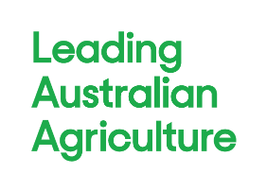 | NFF House  14-16 Brisbane Avenue  Barton ACT 2600 | Locked Bag 9  Kingston ACT 2604 | (02) 6269 5666  reception@nff.org.au  nff.org.au

